**Name:** Muhammad Khubaib

**Python Programing Assignment#1**

**Question 1: Write a Python program that takes a string as input and prints:**

**User_input:Khubaib**

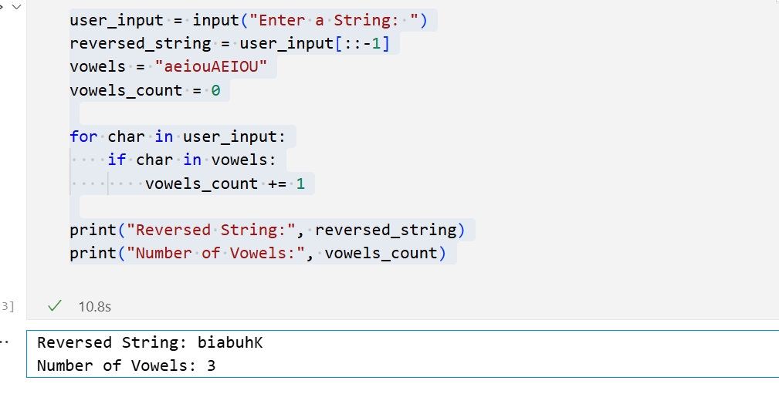

Question 2: Hands-on Coding Project:

**Problem Statement:** Create a Python program that:

* Takes an input number from the user.
* Checks whether the number is even or odd.
* Prints the result.

**1.When Input Enter Even Number 20.**

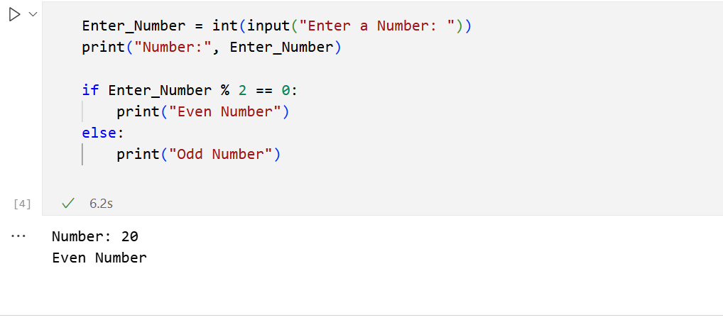

**2. When Enter Input ODD 7 Number.**

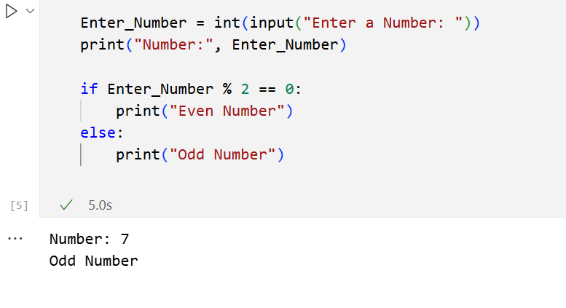

Question 3: Virtual Environment Application:

**Problem Statement:** Create a Python program that:

1. Takes a list of integers as input.
2. Creates a new virtual environment called sortenv.
3. Installs a package (such as numpy) in the virtual environment.

Sorts the list using numpy.sort(). 5. Prints the sorted list.

